Supplementary Material
Supplementary Figure 1: Electrode Localization
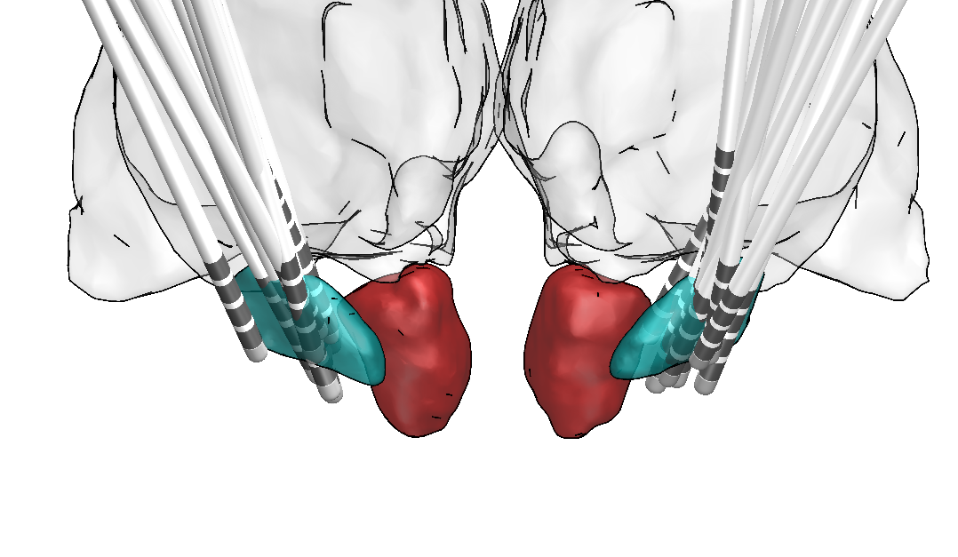
Supplementary Figure 1: Placement of the stimulation electrodes in the subthalamic nucleus (teal) in relation to the thalamus (grey) and the red nucleus (red) as viewed from anterior.
Supplementary Table 1: PD-Patients Characteristics
Nr. | Gender | Age  [years] | Disease Duration [years] | Duration of STN-DBS  [months] | UPDRS-III |  | Stimulation Parameters
 |  |  |  |  | ON | OFF | Stimulation Parameters
1 | M | 50 | 7 | 35 | 22 | 41 | L: case+, 2-, 3-; 4.6V; 90µsec; 210Hz
 |  |  |  |  |  |  | R: case+, 6-, 5-;2.6V; 60µsec; 210Hz
2 | M | 59 | 6 | 24 | 13 | 20 | L: case+, 1-, 2-; 2.4V; 60µsec; 130Hz
 |  |  |  |  |  |  | R: case+, 6-; 1.8V; 60µsec; 130Hz
3 | M | 58 | 9 | 3 | 19 | 37 | L: case+, 2- (60%), 4- (40%), 2.7mA, 60µsec, 130 Hz
 |  |  |  |  |  |  | R: case+, 10-, 2.0 mA, 60µsec, 130 Hz
4 | M | 62 | 2 | 22 | 6 | 13 | L: case+, 2-, 3-; 3.5V; 90µsec; 130Hz
 |  |  |  |  |  |  | R: case+, 10-; 4.0V; 60µsec; 130Hz
5 | M | 68 | 9 | 15 | 11 | 22 | L: case+, 1-; 2.9V; 60µsec; 130Hz
 |  |  |  |  |  |  | R: case+, 5-; 1.3V; 60µsec; 130Hz
6 | M | 57 | 5 | 33 | 25 | 45 | L: case+, 2-, 3-; 3.4V; 60µsec; 130Hz
 |  |  |  |  |  |  | R: case+, 6-, 7-; 3.4V; 60µsec; 130Hz
7 | M | 57 | 9 | 29 | 13 | 22 | L: case+, 1-, 2-; 3.7V; 90µsec; 150Hz
 |  |  |  |  |  |  | R: case+, 5-; 1.5V; 60µsec; 150Hz
8 | M | 46 | 8 | 16 | 11 | 34 | L: case+, 1-; 3.4V; 90µsec; 130Hz
 |  |  |  |  |  |  | R: case+, 5-; 2.7V; 60µsec; 130Hz
9 | M | 67 | 14 | 31 | 21 | 37 | L: case+, 1-; 3.3V; 60µsec; 130Hz
 |  |  |  |  |  |  | R: case+, 5-; 2.7V; 60µsec; 130Hz
10 | M | 50 | 18 | 43 | 21 | 25 | L: 3+, 0-; 3.4V; 60µsec; 160Hz
 |  |  |  |  |  |  | R: case+, 4-, 7-; 3.4V; 60µsec; 160Hz
11 | M | 59 | 9 | 14 | 13 | 33 | L: case+, 2-,1-; 1,25V; 60µsec; 130Hz
 |  |  |  |  |  |  | R: case+, 4-; 1,60V; 60µsec; 130Hz
12 | F | 52 | 5 | 29 | 9 | 28 | L: case+, 2-; 3.0V; 60µsec; 130Hz
 |  |  |  |  |  |  | R: case+, 7-; 4.3V; 60µsec; 130Hz
13 | M | 67 | 15 | 4 | 14 | 40 | L: case+, 3-; 3.7mA; 60µsec; 174Hz
 |  |  |  |  |  |  | R: case+, 11-; 3.7mA; 60µsec; 130Hz
14 | M | 59 | 6 | 12 | 24 | 36 | L: case+, 1-; 2.2mA; 60µsec; 80Hz  case+, 0-; 0.5mA; 60µsec; 80Hz
R: case+, 8-; 0.5mA; 60µsec; 80Hz
case+, 10-; 2.5mA; 60µsec; 80Hz
15 | M | 78 | 11 | 27 | 23 | 44 | L: case+, 2-; 3.7V; 60µsec; 130Hz
 |  |  |  |  |  |  | R: case+, 5-; 2.4V; 60µsec; 130Hz
Mean |  | 59,27 | 9 | 22 | 16,6 | 32,6
(±SD) |  | (±8,31) | (±4) | (±12) | (±6,2) | (±9,4)

Supplementary Table 1: Patient characteristics. M = Male, F = Female, STN-DBS = Deep Brain Stimulation of the subthalamic nucleus, UPDRS-III = Unified Parkinson’s disease Rating Scale Part III, ON = Bilaterally activated Deep Brain Stimulation, no dopaminergic medication, OFF = Bilaterally deactivated Deep Brain Stimulation, no dopaminergic medication, SD = Standard deviation.
Stimulation parameters: L = left electrode, R = right electrode, amplitude (V) or (mA), pulse duration (µsec) and stimulation frequency (Hz).

Supplementary Table 2: Subject Characteristics
 | PD-Patients | Healthy controls | p-value
Gender | 14 M, 1 F | 14 M, 1 F | -
Age | 59,27 (±8,31) | 59,00 (±8,12) | 0,926
MMSE | 29,07 (±1,28) | 28,73 (±1,03) | 0,558
PANDA | 23,92 (±4,82) | 23,87 (±6,15) | 0,608
Hypomania Checklist | 8,38 (±5,01) | 12,20 (±9,01) | 0,080
BIS-11 | 60,87 (±9,19) | 63,87 (±9,50) | 0,636
BDI-II | 7,87 (±7,10) | 4,93 (±3,94) | 0,044
Years of Education | 14 (±2,2) | 15,4 (±2,5) | 0,115

Supplementary Table 2: Subject characteristics. M = Male, F = Female, MMSE = Mini-Mental State Examination, PANDA = Parkinson Neuropsychometric Dementia Assessment, BIS-11 = Barratt Impulsiveness Scale, BDI-II = Beck Depression Inventory, PD = Parkinson’s Disease

